This is my walkthrough for my Windows test network:

Part 1: Setting up Windows Server 2022

Step 1: Downloaded the newest version of Virtualbox being 7.0.12 currently.

Source: <https://www.virtualbox.org/wiki/Downloads>

**Image:** 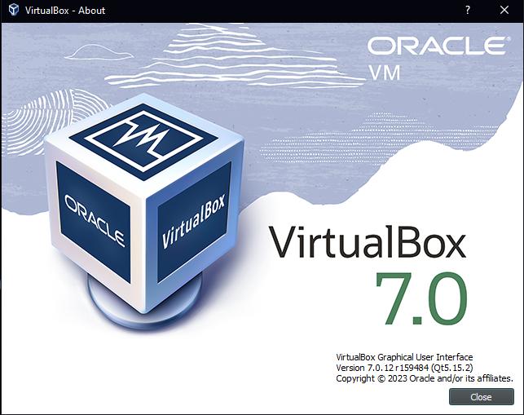

Step 2: Found two iso files for a Windows Server 2022 trial and a Windows 10 Enterprise trial and downloaded those after signing up for the trial.

Source: (Server) <https://www.microsoft.com/en-us/evalcenter/evaluate-windows-server-2022>

(Enterprise) <https://www.microsoft.com/en-us/evalcenter/evaluate-windows-10-enterprise>

Step 3: Setup a new VM in Virtualbox and linked my Windows Server 2022 ISO file to it and provided the VM with 4GB of RAM and 2 CPUs with a 50GB storage drive.

**Images:** 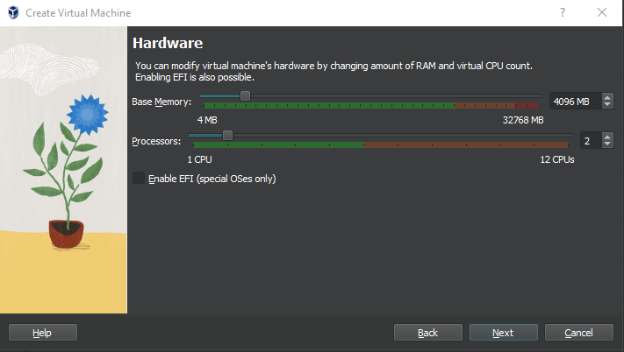

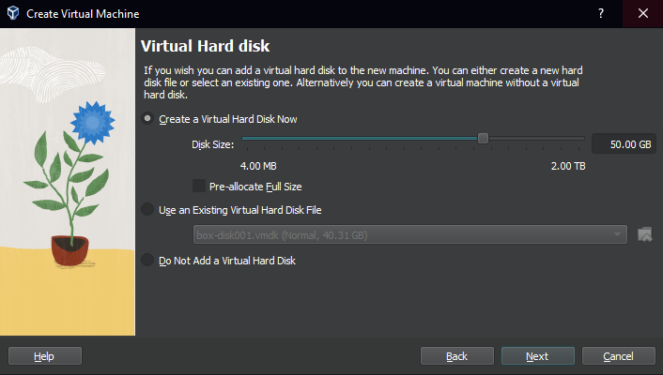

Step 4: I chose the version of the Windows Server I would like to use which was the Windows Server 2022 Standard Evaluation (Desktop Experience) edition. Accepted the terms and chose the 50GB drive I made previously for the partition. Then an administrator account was made with a password of my choosing and then I had a functioning windows Server VM for me to use.

Step 5: I installed the Active Directory Domain Services Role. To do this I went to the Server Manager application, selected Add roles and features, went through the prompts until I got to where I selected which features I want and selected the ADDS Role. I finished through the prompts and completed the installation.

**Images:**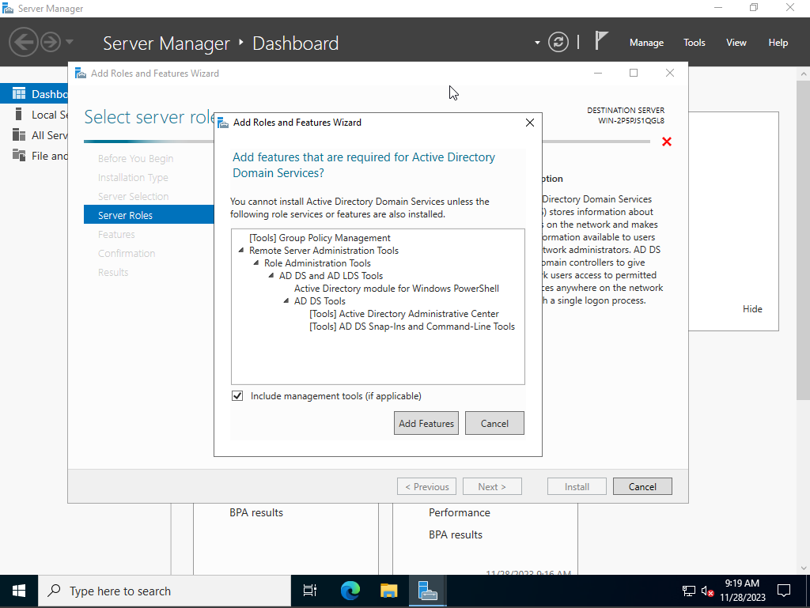

Step 6: I promoted the server to a domain controller via the notifications tab after the install from the previous step was completed. Set the domain name to TEST and continued through the prompts and completed the installation.

**Images:**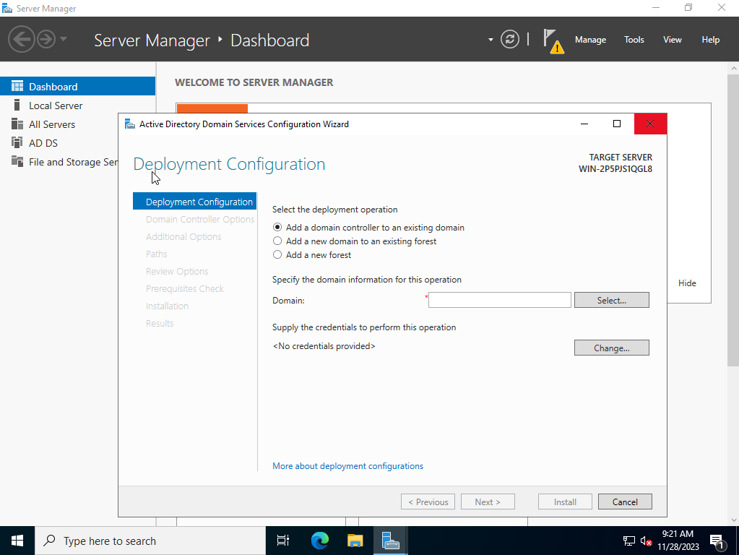

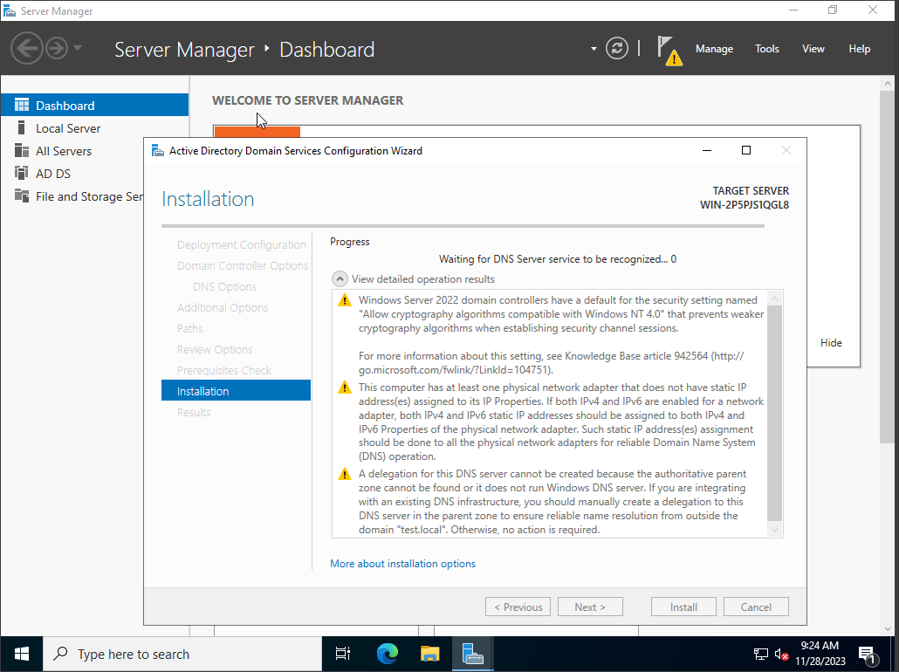

Step 7: Verified that the previous step was successful and that I could log in to the domain with the admin account and see my domain listed in the Active directory Administrative center.

**Images:**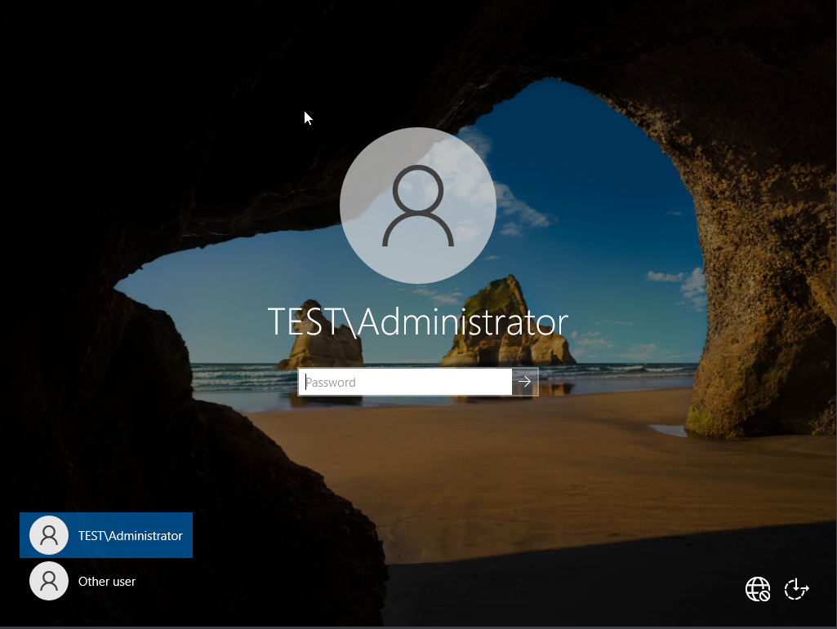

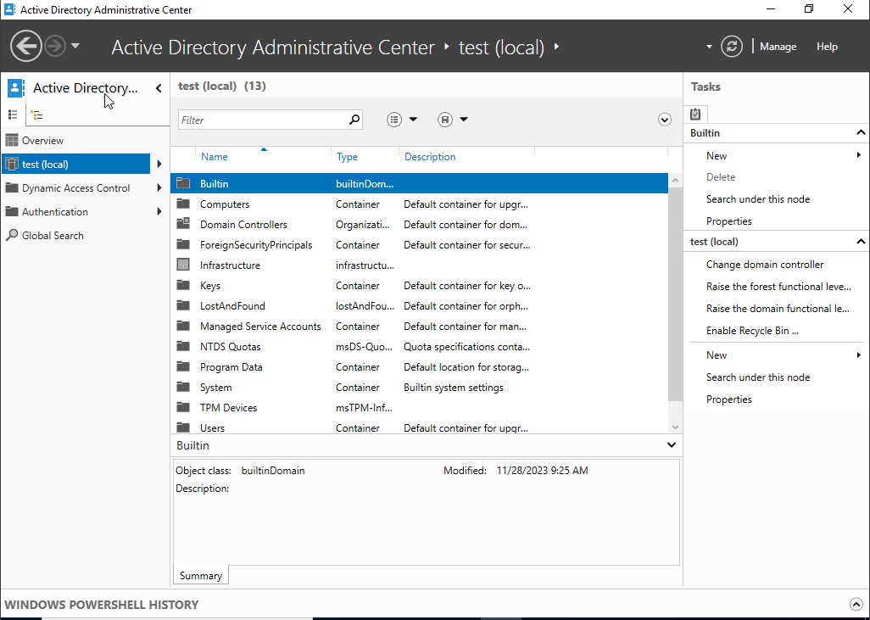

Step 8: I then closed my VM and set up a second network adapter on the Virtualbox interface. One for NAT and one for Intranet.

**Images:**

Step 9: I relaunched the VM and went to network settings and changed the internal network IP to 172.16.0.1 and the subnet to 255.255.255.0. This way my client VM can access the server VM internally.

**Images:**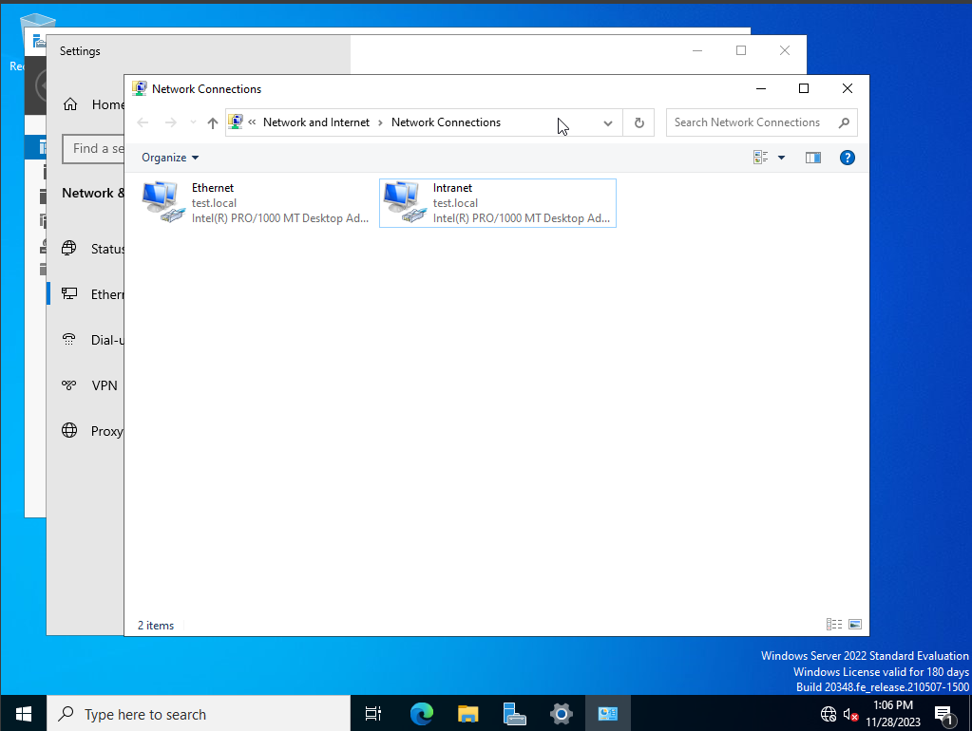

Step 10: I then set up RAS/NAT. This allows my client vm to connect to the internet while still connecting to the internal network.

**Images:**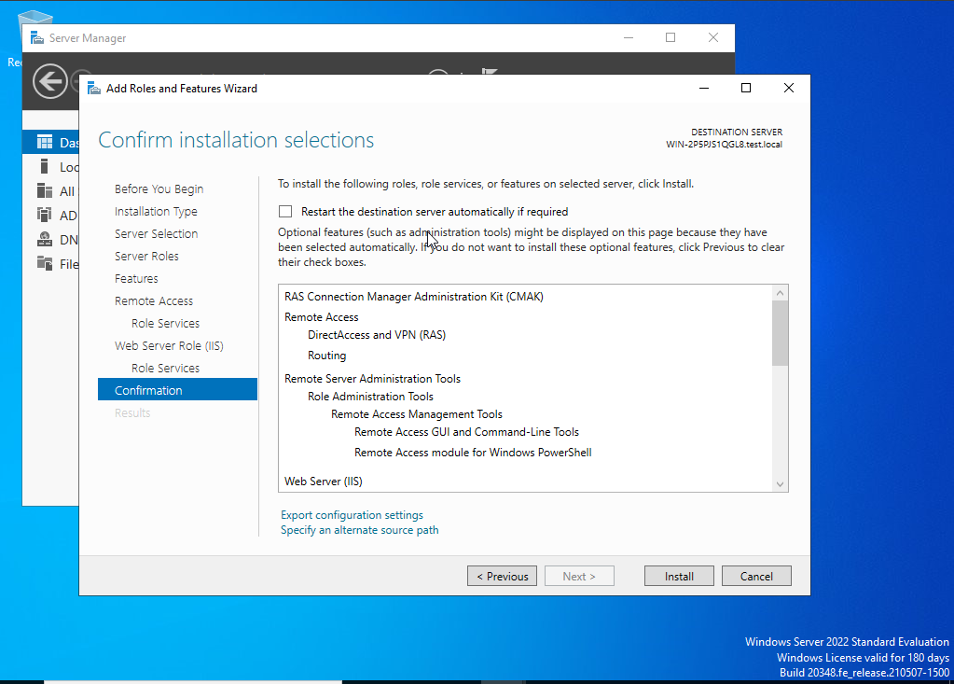

Step 11: I set up the DHCP server to assign IP addresses automatically to my client VMs and act as the default gateway.

**Images:**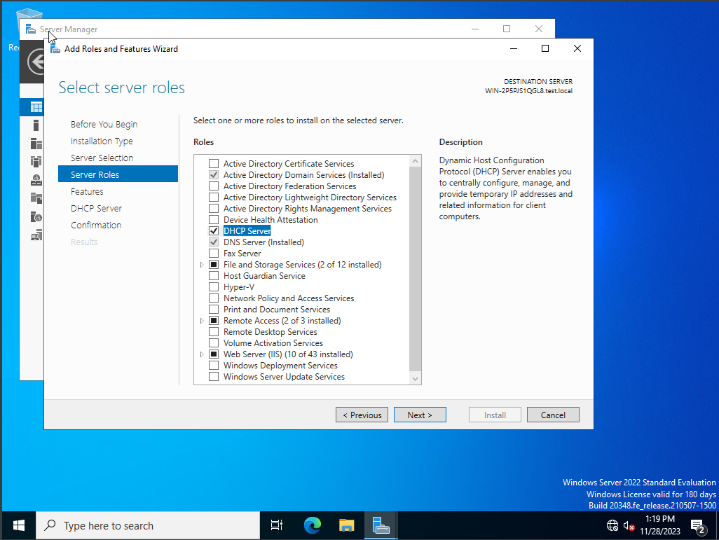

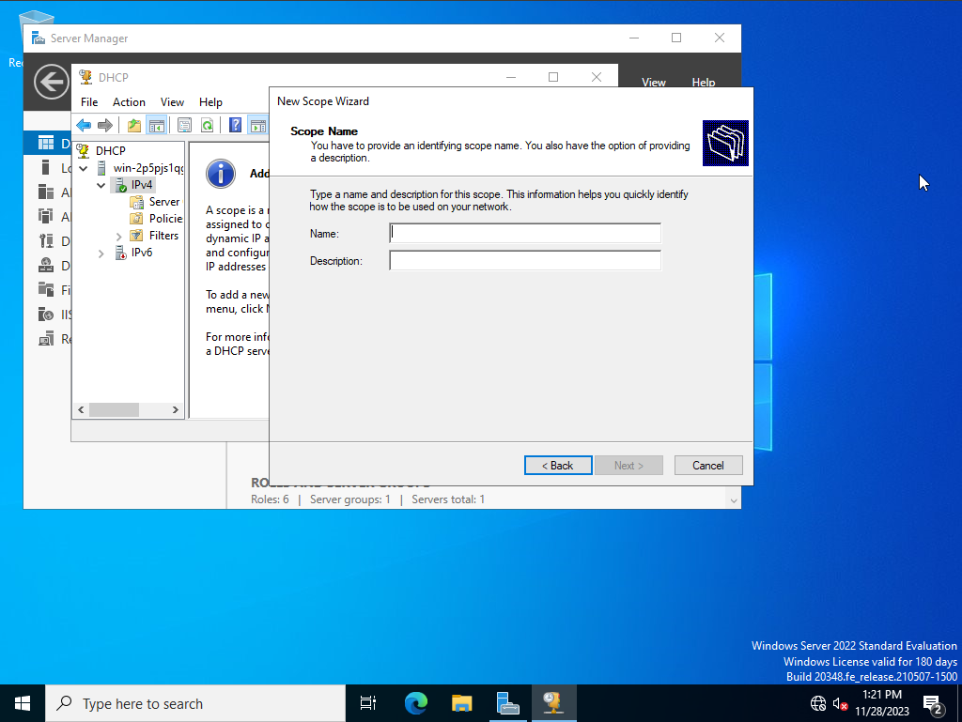

Step 12: I then used a powershell script I found on a github page to inject a bunch of extra users into my active directory to make it look more like a company. I also made an ADMINS OU and made a Ryan User that I would connect to from my client VM. User added to Domain Admins

**Source:** [**https://github.com/digital-dogma/create-users-with-ps-script**](https://github.com/digital-dogma/create-users-with-ps-script)

**Images:**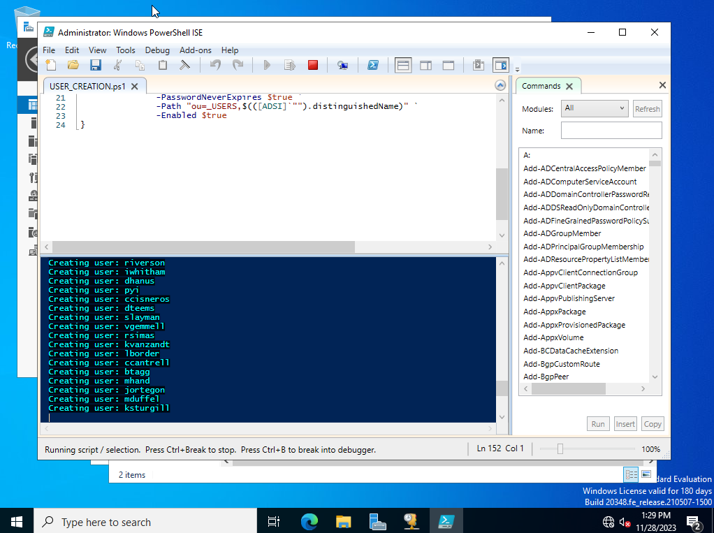

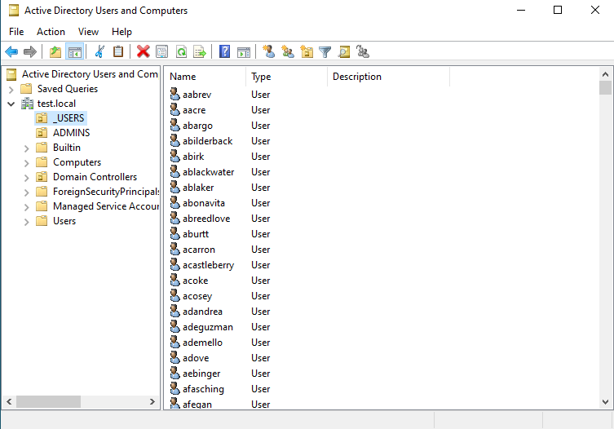

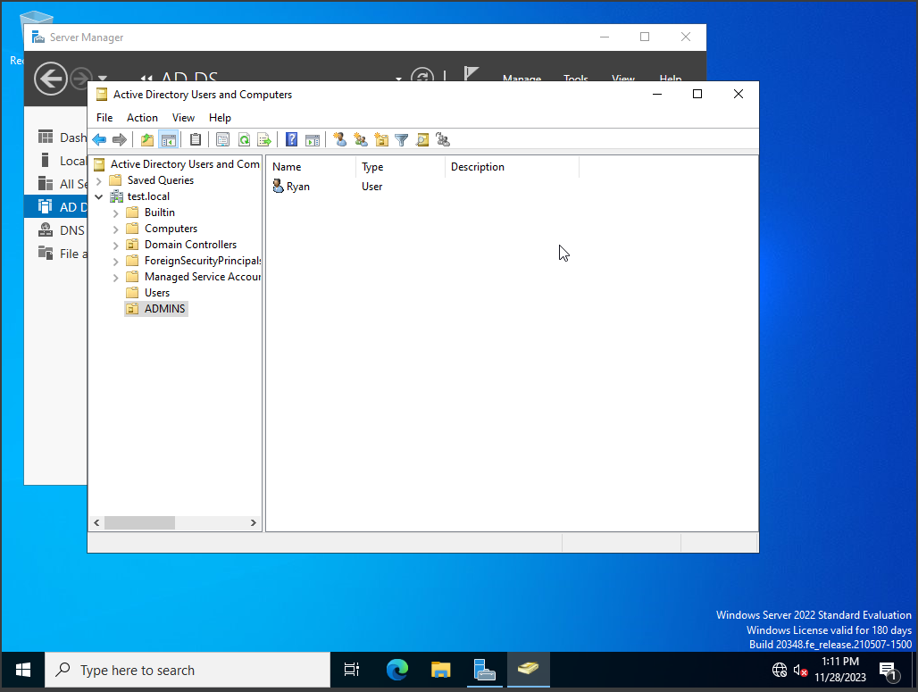

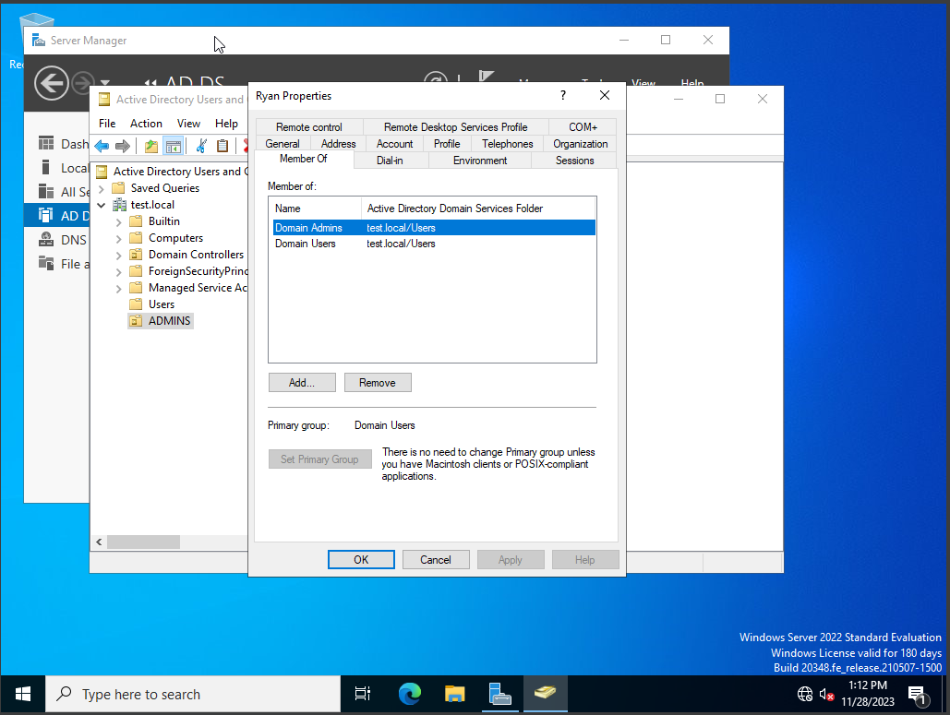

Part 2: Setting up Windows 10 Enterprise and joining the domain

Step 1: I set up the Windows 10 Enterprise VM in Virtualbox. I gave it the same settings as the server, being 2 CPUs, 4GB of RAM and a 50GB storage drive. I also set up the second adapter just like the server VM so that the internet and the internal network could be accessed.

**Images:**



Step 2: Went through the Windows installation prompts and selected Domain join and created an account.

**Images:**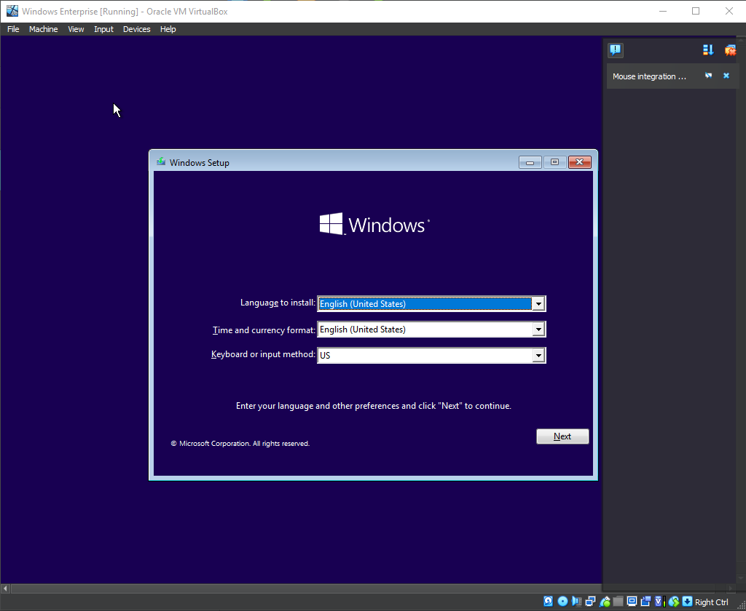

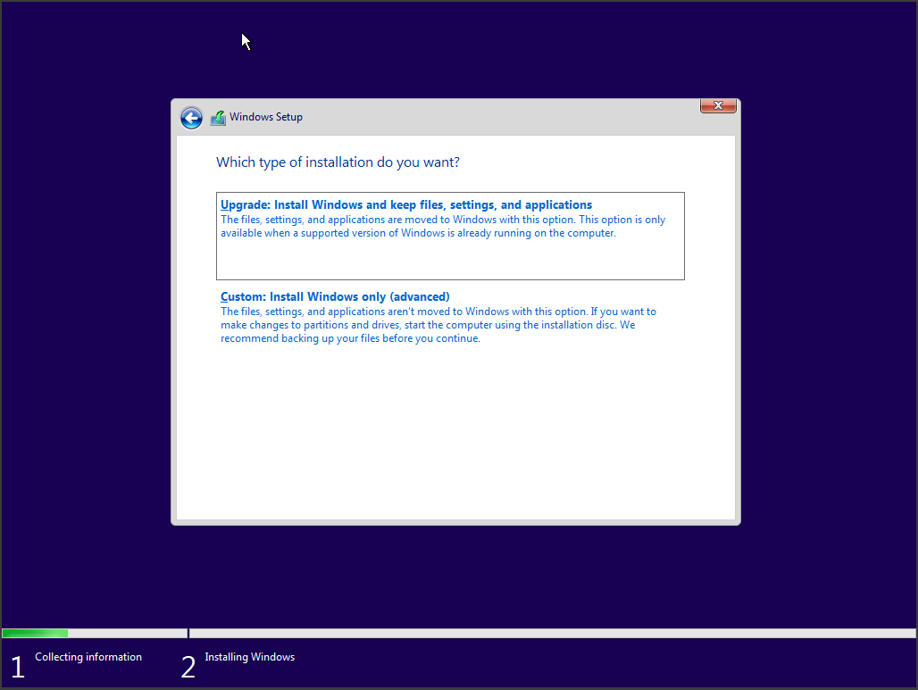

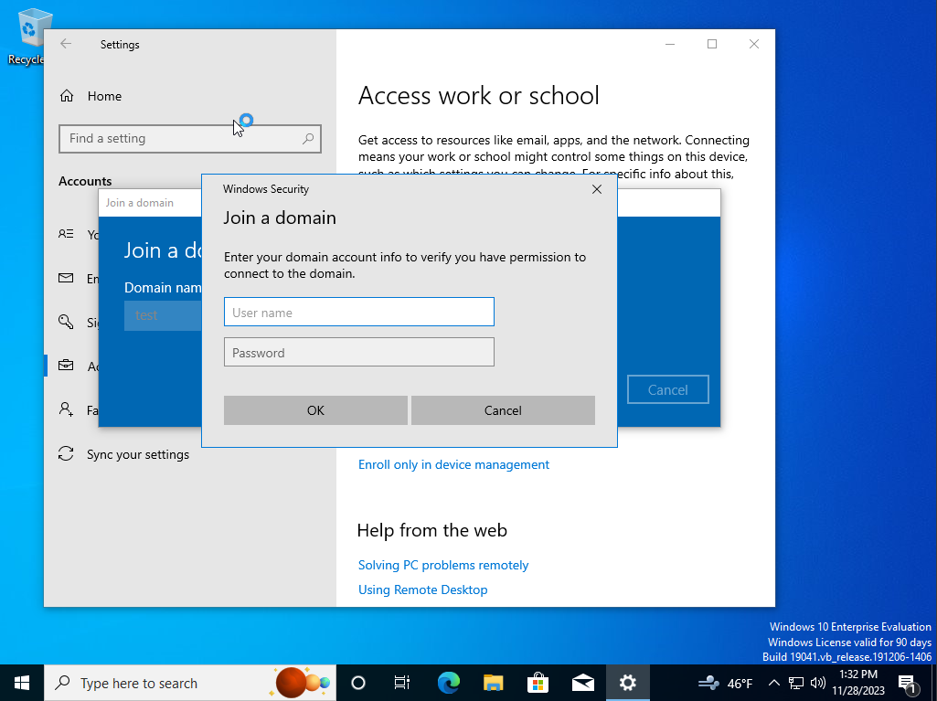Step 3: I made an account just to be signed into windows. I then joined into the domain with an account I had created as an Admin account. I also verified that my network connections were correct and that I could access the internet and that I was connected to the test.local domain connection.

**Images:** 